1st December 2017

**FIA WTCC Season Finale in Qatar**

Tonight’s night race in Qatar’s Losail circuit, will decide who is crowned as new FIA World Touring Car Champion. The final two races of the season will culminate the long months of intense preparation and competition, filled with drama, thrills and spills, hopes and disappointments. The Swedish Thed Björk and the Hungarian Norbert Michelisz will face-off in a season finale that is promising to flare up the spirits and the dark night in the desert. Björk holds a narrow 6.5pt lead but Michelisz has the experience and the fastest free practice time.

To add some additional spice, Four times World Champion Yvan Muller is also coming back to support the Swedish Volvo Polestar team, whom he has been advising throughout the season and will now take a direct role behind the wheel, as they aim for the manufacturers title too. A notable absence however is that of Tiago Monteiro who is unfortunately still nursing injury and will only be watching from the sidelines.

The FIA WTCC boasts the Japanese Tyre manufacturer YOKOHAMA as official Tyre supplier. “We are very excited with these 2 remaining races of the Championship. We are pleased with the way the season has gone. Our Motorsports support specialists have worked closely with all the teams providing the technical expertise and recommendations to ensure safety and high performance. For this reason, all we can do is wish all the competitors the best of luck and may the best one win”. Added David Oliva, responsible for Communications at YOKOHAMA Europe. “This Championship is about ensuring consistent high performance under very demanding competitive circumstances”, which is what our tyres deliver.” He concluded.

Björk and Michelisz are among six drivers still in contention for the world title in Qatar tonight. Mehdi Bennani, Nicky Catsburg, Tom Chilton and Esteban Guerrieri can also take the crown. In the challenge to win the FIA World Touring Car Championship for Manufacturers, Volvo Polestar leads Honda by 12.5 points, while Chilton is half a point ahead of his Sébastien Loeb Racing team-mate Bennani in the WTCC Trophy.

The Opening Race is scheduled for 21h20 local time with the Main Race following at 22h35.

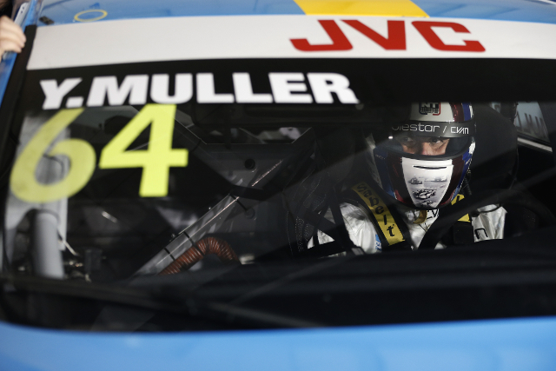

*4 Times World Champion Yvan Muller is back photo Michel Le Meur*

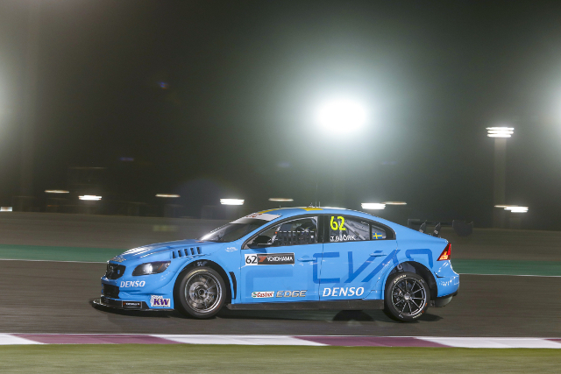

*Bjork strong leader and title contender Photo Francois Flamand*

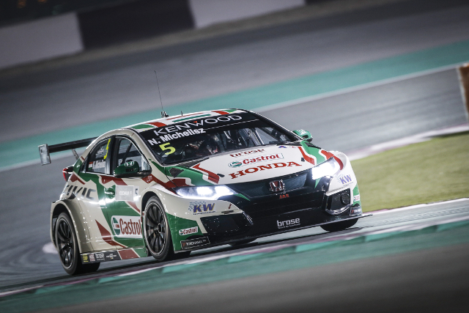

*Norbert Michelisz aiming high at FIA WTCC Photo Francois Flamand*

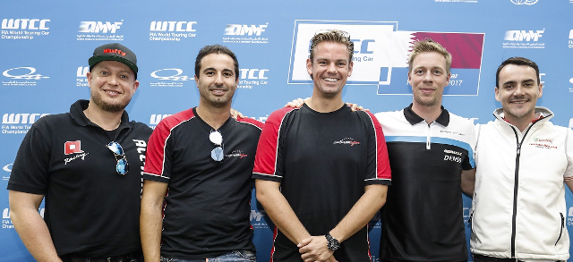

*Some of the WTCC Top Drivers on final showdown in Qatar Photo Francoise Flamand*